Student Activity
26 Series circuits

TASK
To investigate the addition of resistors in a series circuit.

THEORY
The value of the total resistance in a series circuit can be found from the individual values.

EQUIPMENT
• power supply
• DC voltmeter (0–10 V) or voltage sensor
• DC ammeter (0–1 A) or current sensor
• 3 resistors of unknown resistance (resistors rated 2 W or more are suitable)
• connecting wires

NOTES ON METHOD
ICT
Most current sensors have a 1 A range and are suitable for this experiment. They are generally current-protected, but take care to check the manufacturer’s specifications, and use sensors with care. Exceeding the maximum current rating will permanently damage an ammeter or sensor.
Sample rate: As only comparative values are required, the default rates of your equipment or manual sampling are suitable.
Use a digital display to view and record instantaneous values.

1. Connect a circuit containing just one of the unknown resistors, the voltmeter and ammeter (or voltage and current sensors) and the power supply.
Set the power supply to 6 V, turn it on and measure the potential difference and current in the circuit.
Record these results.

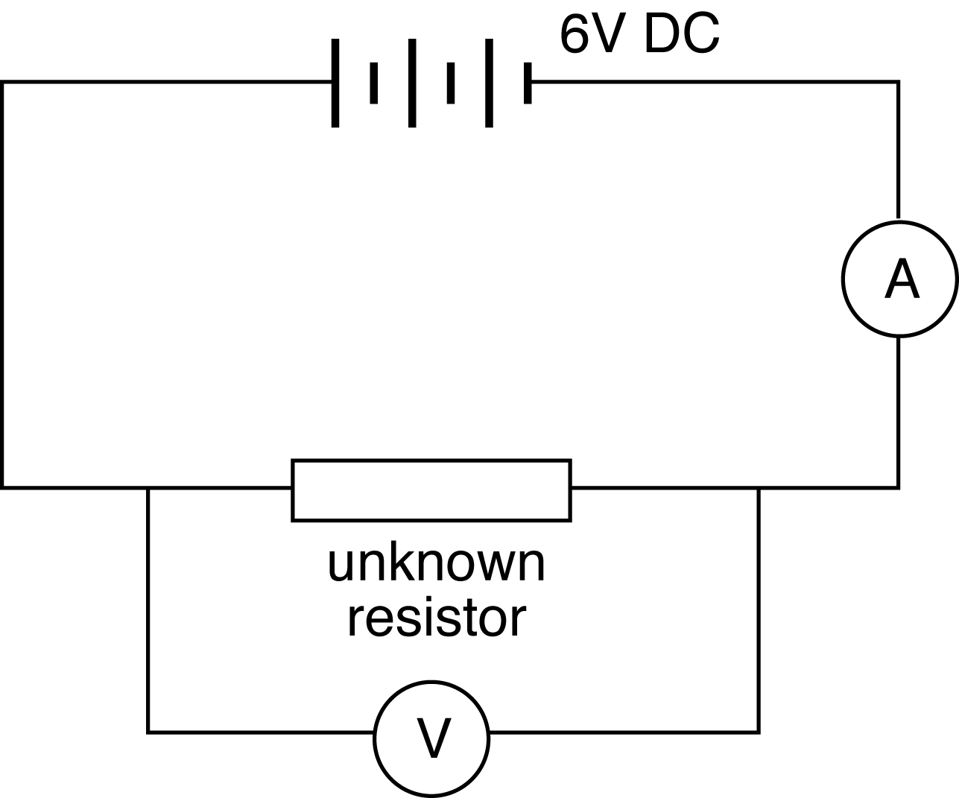
2. Add the second resistor to the circuit, in series with the first.
Measure the current in the circuit, the total potential difference across both resistors, and the individual potential difference for each resistor.
Record these results.

3. Finally, add the third resistor, in series with the first two.
Measure the current in the circuit, the total potential difference, and the individual potential difference for each resistor.
Record this last set of results.

DATA & ANALYSIS
Collate your measurements from each circuit.
Calculate the resistance of each resistor separately and in combination with the additional resistors in series.

Does this support what you expected?
Summarise and comment upon your results.
26 Series circuits
continued
CONCLUSION
What do your results suggest is the relationship between individual resistance and total effective resistance in a series circuit?

QUESTIONS
1. Do the values found for the resistance of each individual resistor match the indicated value? Check the expected values with your teacher and account for any discrepancies.
2. Make a list of the errors that could reasonably affect the results of this experiment. Comment on each.

